The following Gantt chants are dated revisions from the beginning to the end of project. Initially, the Gantt Charts were fairly vague because the group did not have a solid idea how long each milestone would take. As the project neared to its end, the Gantt charts became more sophisticated.

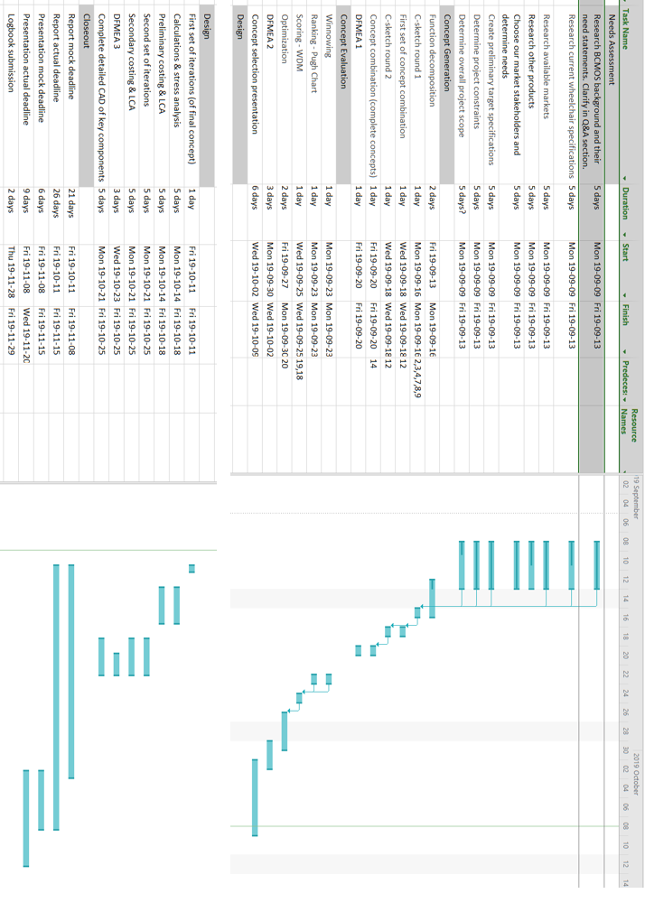

Figure 1: Initial Gantt chart from September 8 - 15

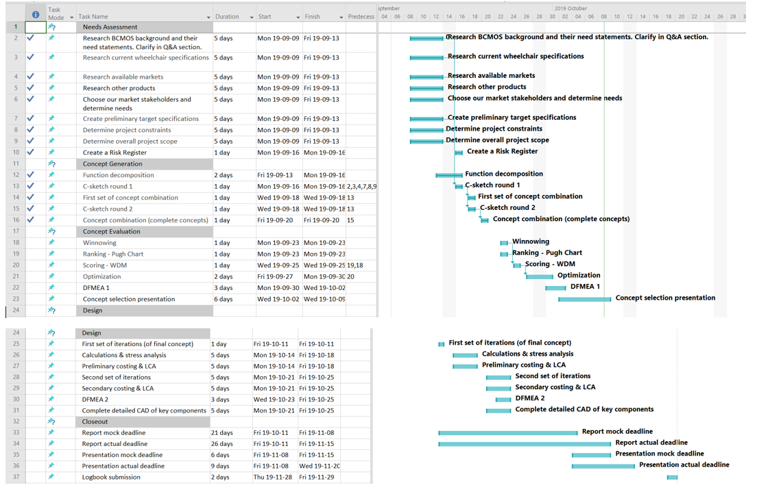

Figure 2: Revised Gantt chart from September 16 - 22

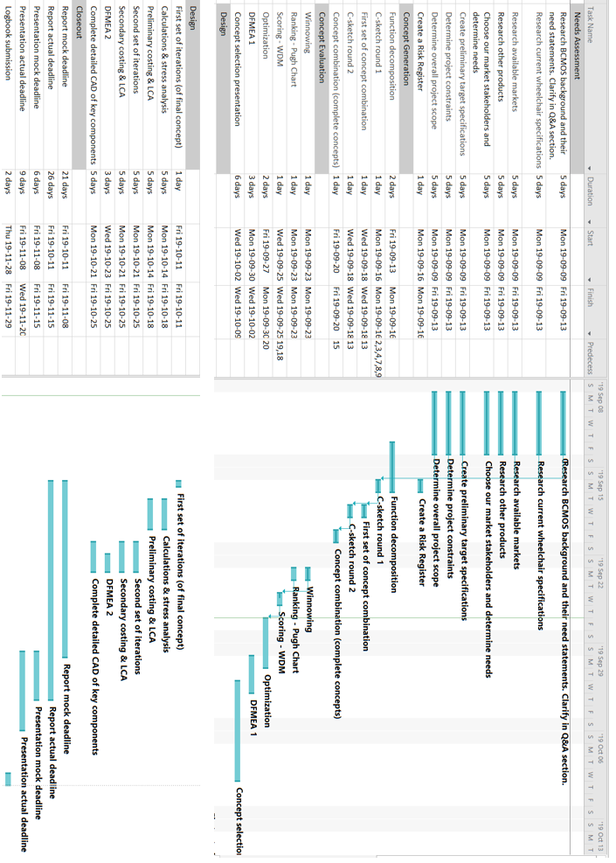

Figure 3: Revised Gantt chart from September 23 - 29

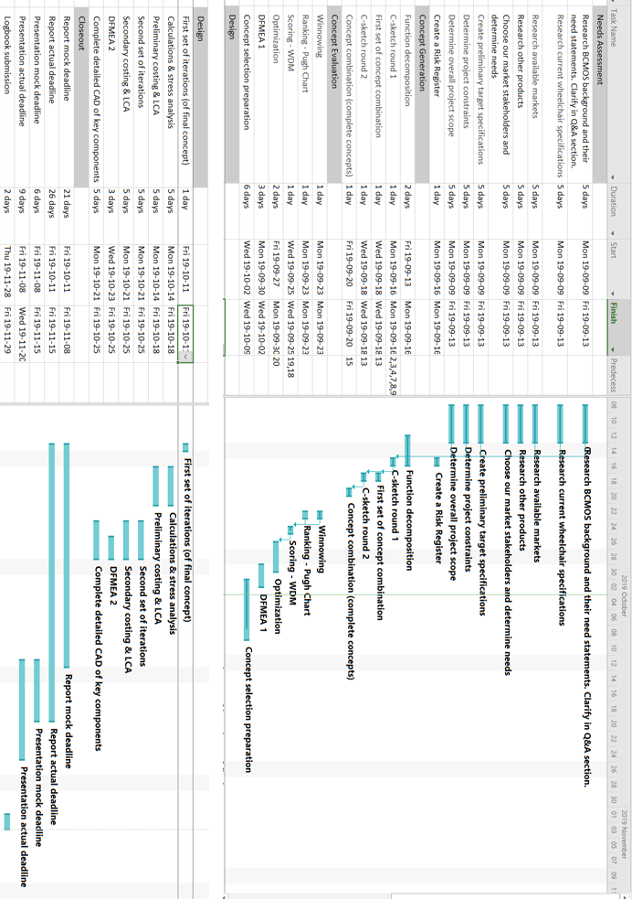

Figure 4: Revised Gantt chart from September 29 - October 6

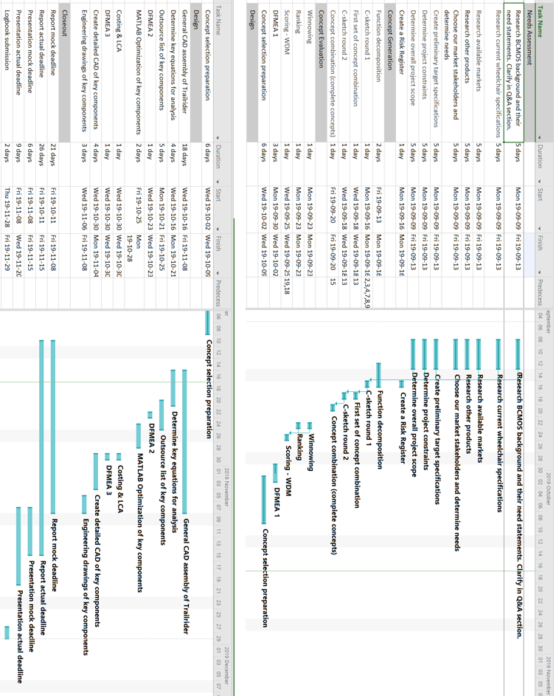

Figure 5: Revised Gantt chart from October 6 - 20

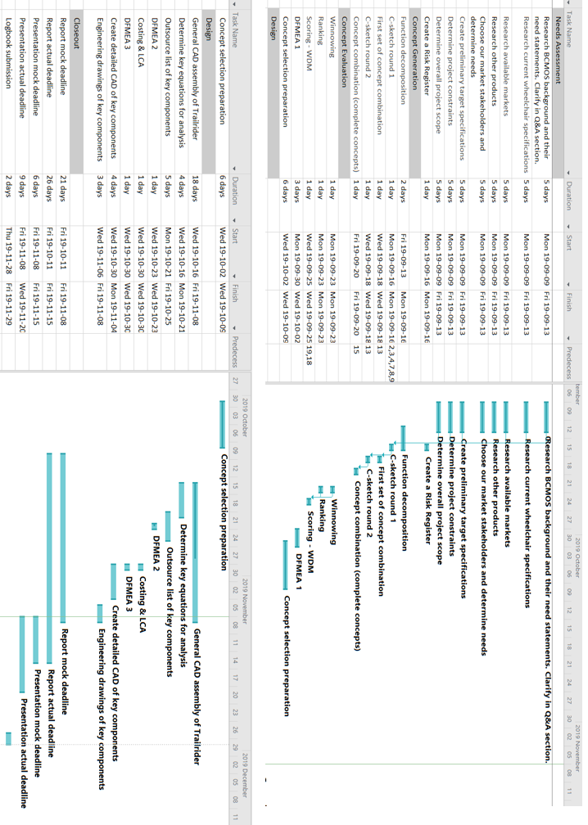

Figure 6: Revised Gantt chart from October 20 -27

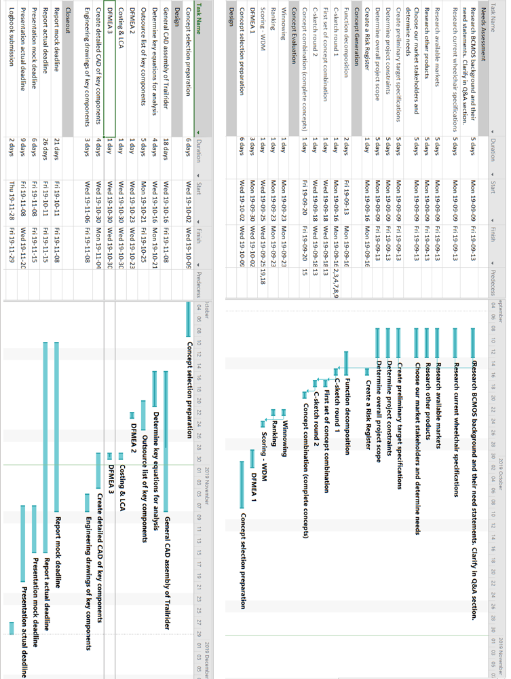

Figure 7: Revised Gantt chart from October 28 - November 3

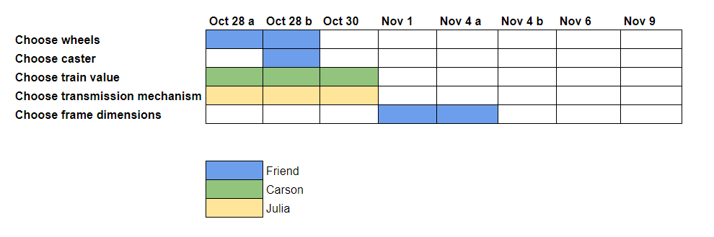

Figure 8: Supplementary improved Gantt chart for the week of October 28 - November 3

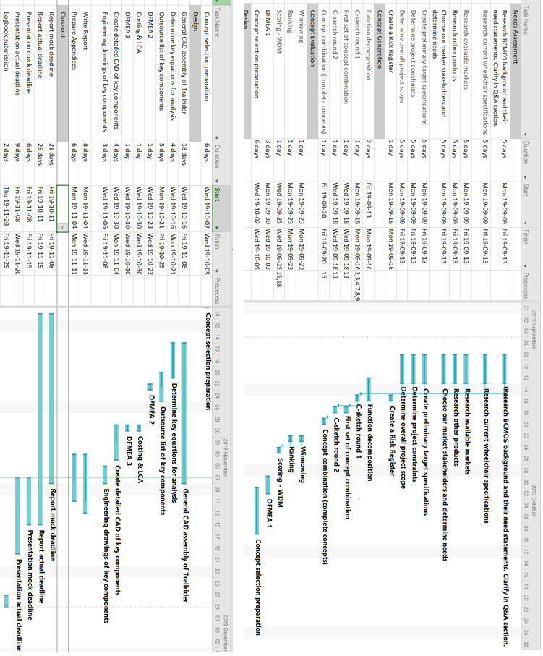

Figure 9: Revised Gantt chart from November 4 - 10

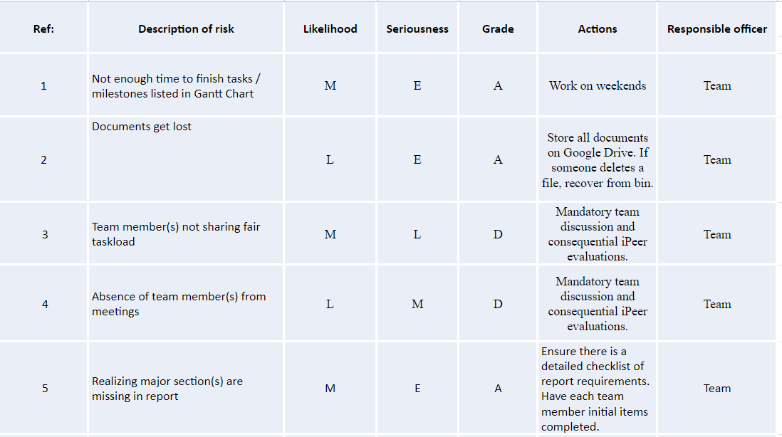

Figure 10 : Risk Register